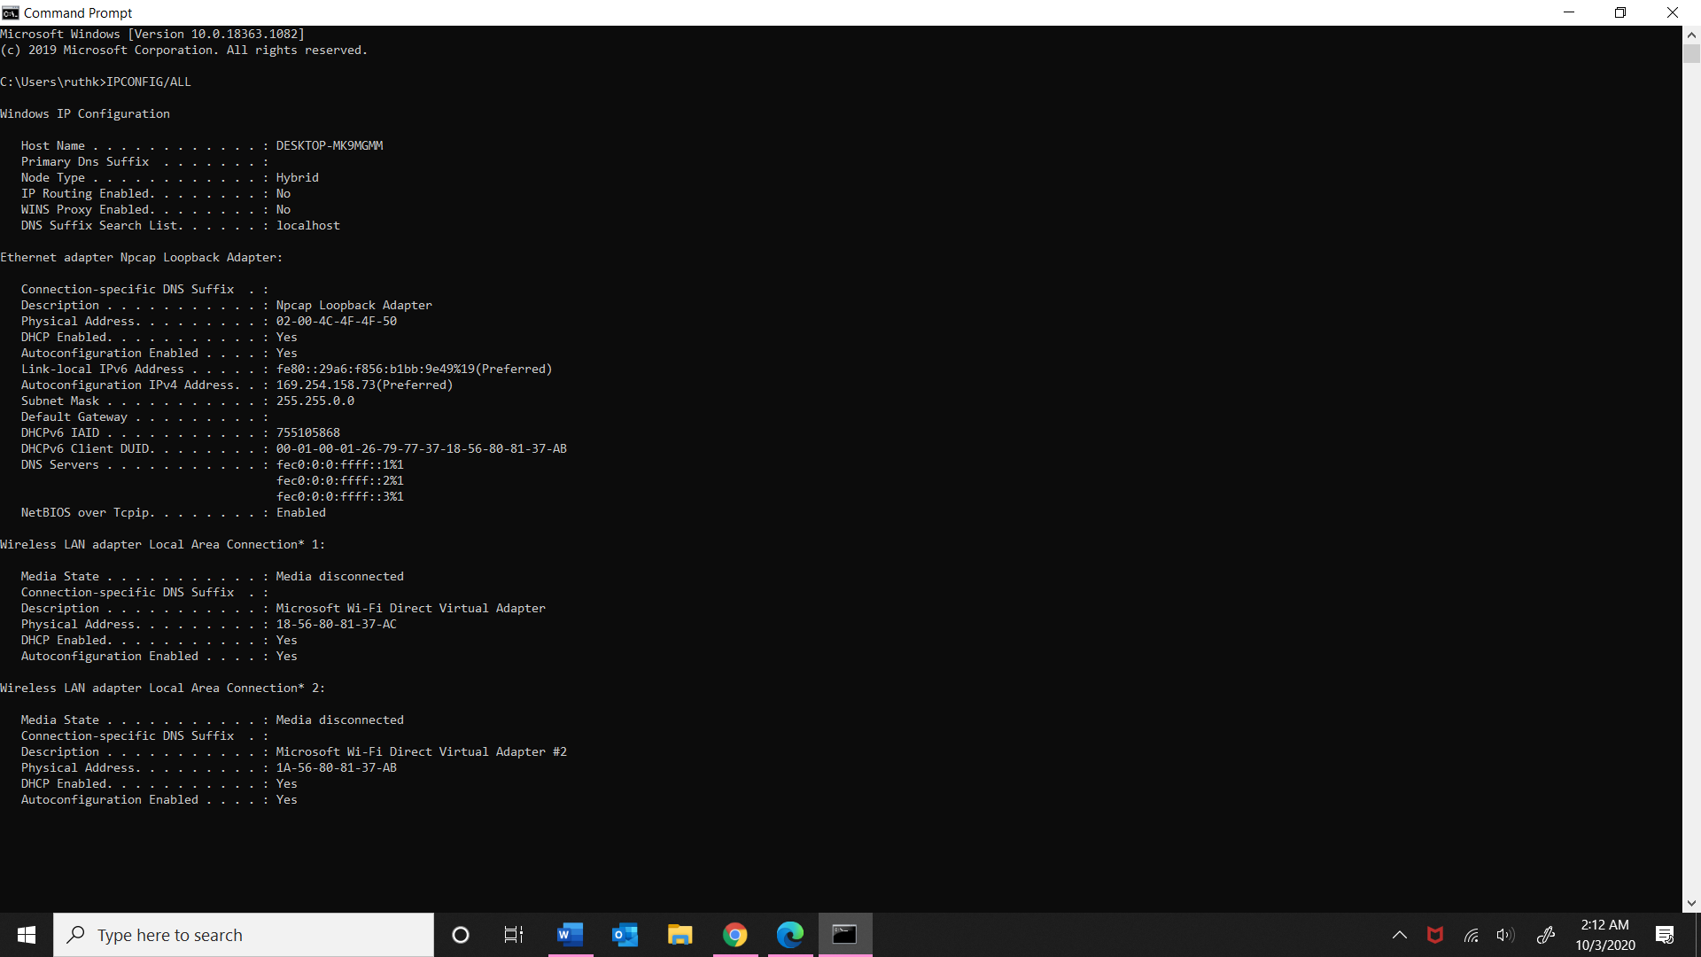

1. IP:10.219.157.11

Subnet mask:255.255.128.0

Default gateway: 10.219.128.1

MAC:18-56-80-81-37-AB

1. These numbers serve a purpose to allow a computer to connect to the internet. They all belong in the network layer. The IP and MAC helps our computer unique on a network. It is impossible to connect to the internet without these numbers.

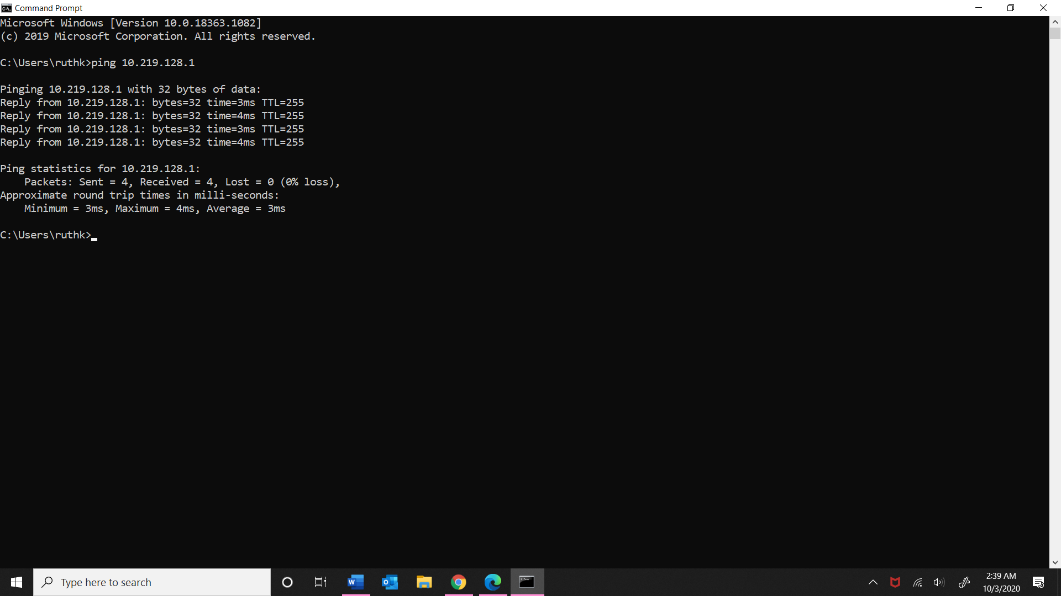

1. 4 packets received. Took an average of = 3ms.

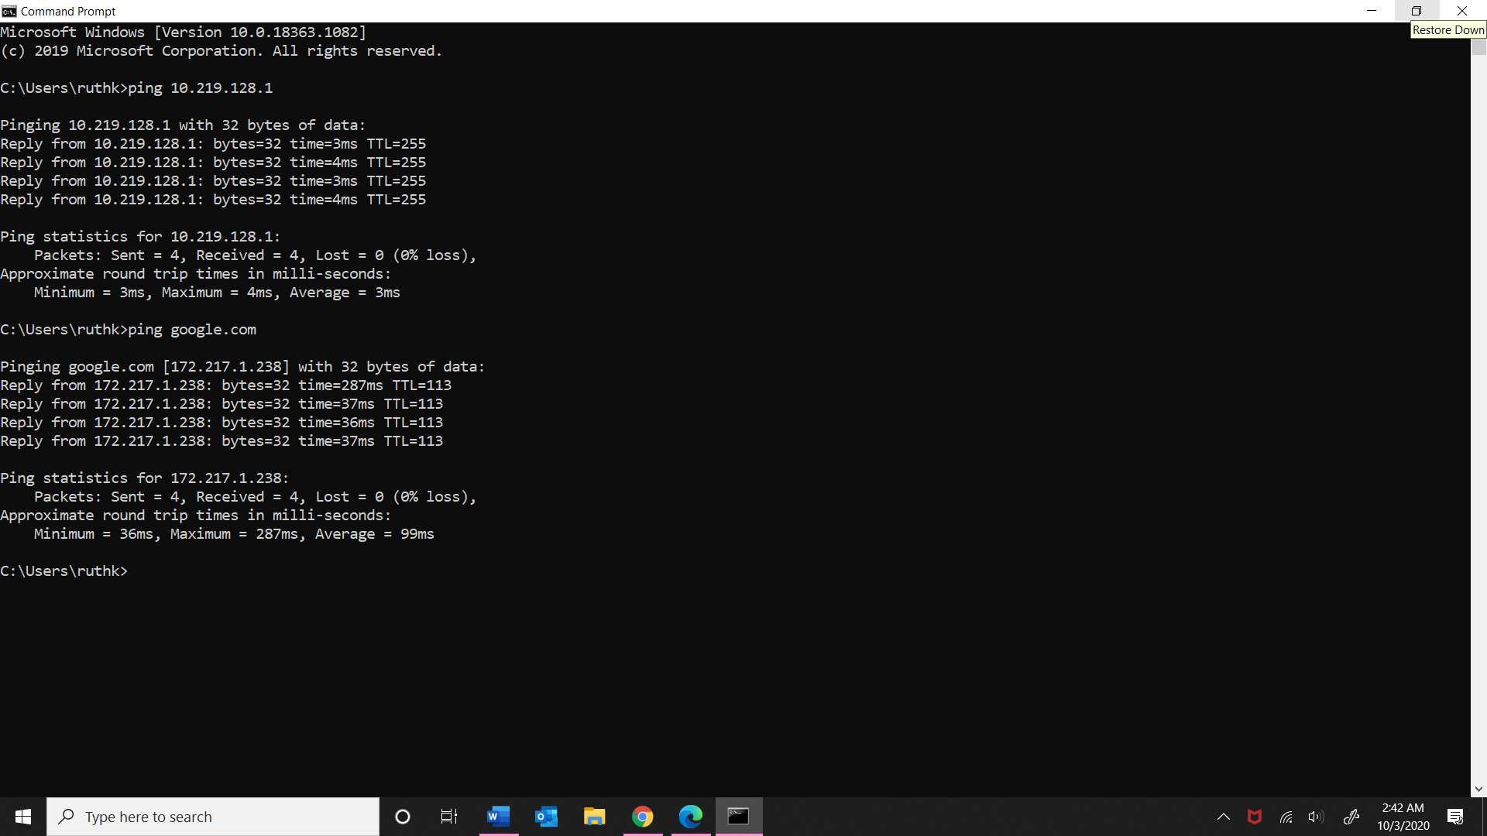

1. 4 packets received. Took an average of= 99ms

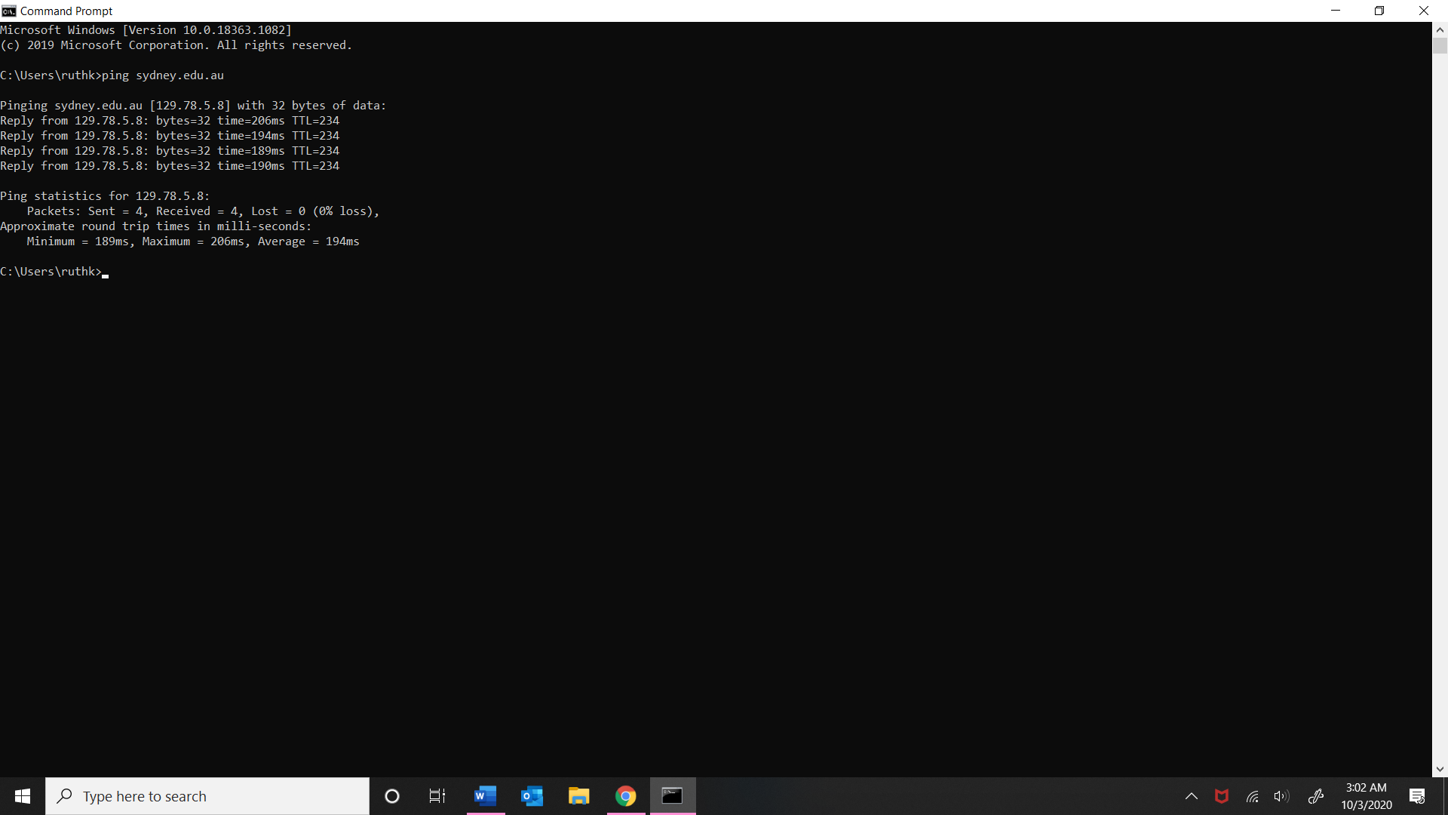

1. Received 4 packets. Took average of 194ms.